RIPHAH INTERNATIONAL UNIVERSITY, ISLAMABAD


Lab # 9
Bachelors of Computer Science – 6th Semester
Subject: Operating System

Submitted to: Ms. Kausar
Submitted by: Ammara Tahir_ 41345
Date of Submission: 22- Oct -2024

Exercise 1:
Run following script. And examine output. 01

#!/bin/sh
clear
date > lab8
echo -e "lab8 file contains:"
cat < lab8

Answer

lab9 file contains:
Mon Oct 21 10:34:56 UTC 2024

Exercise 2:

A file contains following script. Execute this code. 01

#/bin/sh

x=5
y=0
echo "The value of X = " $x
y=$(expr $x + 5)
echo "The value of Y = " $y

Answer

The output of the above program is

The value of X = 5
The value of Y = 10

Exercise 3:

Write shell script that reads 2 integer values from user and print their sum on screen. 02

Answer

#!/bin/sh

# Read two integers from the user
read -p "Enter first number: " num1
read -p "Enter second number: " num2

# Calculate and print the sum
echo "The sum is: $((num1 + num2))"

Exercise 4:

Write shell script that takes string from user, and make folder with named with string. Folder should contain file with named timestamp. Having current time and date written on it. 02

Answer

Code:
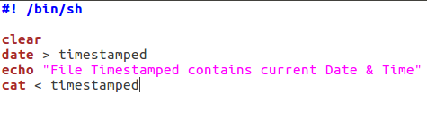
Commands:

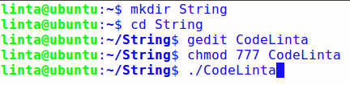
Output:
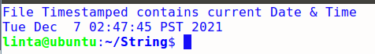

Date Saved in file “TimeStamped”:

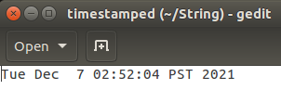

Exercise 5:

Write a shell script to get the total count of the word “Linux” in all the “.txt” files and also across files present in subdirectories. 02
Answer

The following is the test script/command which recursively searches for the “.txt” files and returns the total occurrences of a word <Linux>.
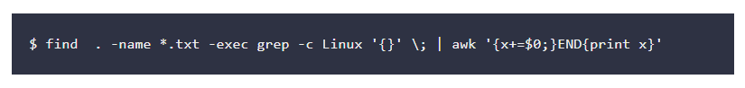

Exercise 6:

Write shell script that defines 2 integers and one float value like
a=5
b=7
c=5.5
Perform multiplication of integers then divide with float.
and finally print result with four decimal places. like 6.3636
you have to use pipe operator ( | ) to send variables to bc utility for arithmetic. 03

Answer

#!/bin/sh

# Define two integers and one float
a=5
b=7
c=5.5

# Perform the multiplication of a and b, then divide by c
result=$(echo "scale=4; ($a * $b) / $c" | bc)

# Print the result with four decimal places
echo "The result is: $result"

